APPENDIX A
PICTURES TAKEN AT FIRST EXPLORATION AND PETRLOLEUM DEVELOPMENT COMPANY LIMITED’S FACILITY AT ABIGAIL JOSEPH FPSO, OFFSHORE-BAYELSA STATE ON 11TH FEBRUARY, 2026.
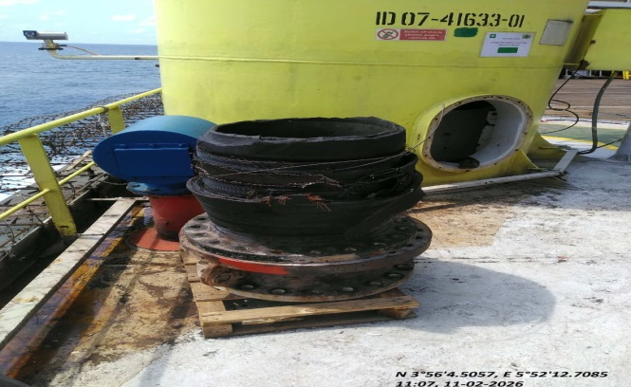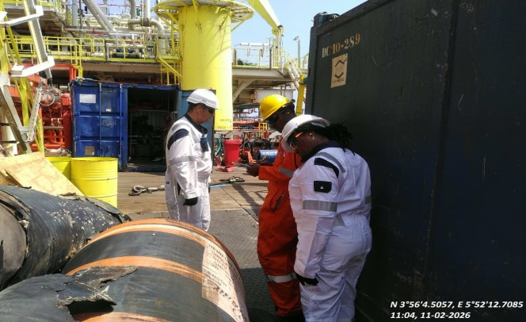
FIG. 1: PART OF THE DAMAGED 20” LOADING HOSE. FIG. 2: A SECTION OF THE DAMAGED 20” HOSE.
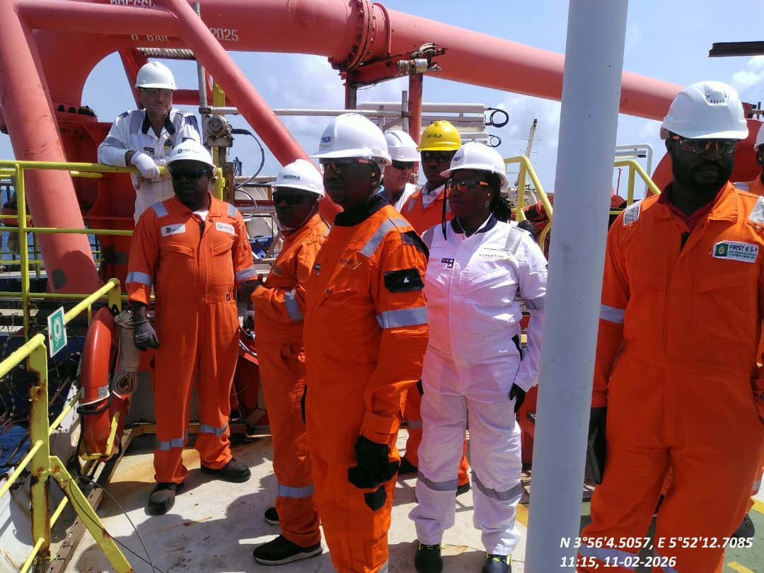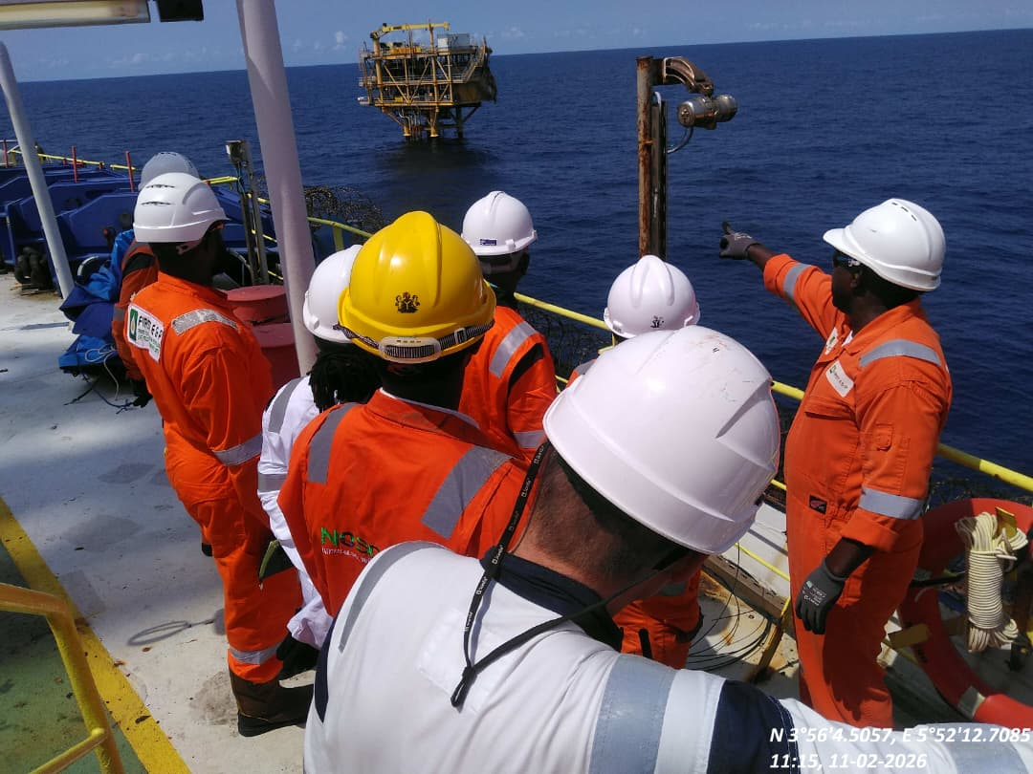
FIG. 3: THE INCIDENT POINT (LOADING POINT) FIG. 4: A SECTION OF THE DAMAGED CSP BEING SITED
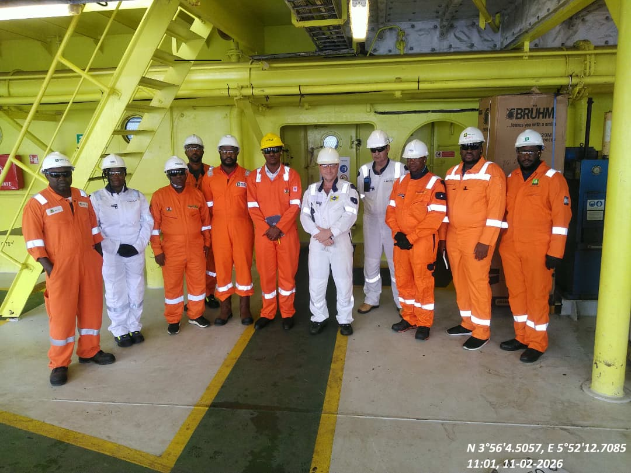
FIG. 5: THE INSPECTION TEAM COMPRISING NOSDRA, NUPRC, BYSMENV, NUIMS AND FIRST E& P REPS.

